TQS: Product specification report
Flávia Figueiredo [88887], Pedro Marques [89069], José Frias [89206], Tomás Batista [89296]
v2020-05-06

1 Introduction 1
1.1 Overview of the project 1
1.2 Limitations 1
2 Product concept 2
2.1 Vision statement 2
2.2 Personas 2
2.3 Main scenarios 2
2.4 Project epics and priorities 2
3 Domain model 2
4 Architecture notebook 3
4.1 Key requirements and constrains 3
4.2 Architetural view 3
4.3 Arquitetura de instalação 3
4.4 System architecture 4
4.5 API for developers 4
5 API de integração 4
6 References and resources 4

Introduction

Overview of the project
The proposed application is a marketplace for houses, rooms or apartments, with a special attention directed to students. The Homies Marketplace will help the people that are looking for a place, showing all the information related to it, like the topology, price, characteristics or ratings of the place, allowing an user to take a more informed decision of its future house. As soon the user decides which house(s) apply to his criteria, it can contact the owner of the determined place and schedule a meeting or book the place.
With this service, finding a new house can save a lot of time, being that the people interested don’t have to go to the desired place and start searching. Instead, with this centralized service, the book can be made in a remote and more easy way.
Concerning the availability and displaying of the places, its owner can publish information about its house, specifying its characteristics, in order that the users that are searching are presented to a rich list of possible choices and take the best decision.

Limitations
<explain the known limitations/unimplemented (but planned) features>
This service don’t provide a payment mechanism??.

Product concept

Vision statement
The system, after the user is registered and logged in the service, will be used to search for places, having the possibility of contacting its owner. This search can be done by specifying some house characteristics, like price or number of rooms, suppressing the difficulties encountered when searching for a new house, as well the difficulty of taking the best informed decision without a tool that provides data. When it encounters a place that is related to his preferences, it can book and reserve the place immediately, only having to wait for the owner confirmation, or if preferable, contact the landlord and schedule a meeting. Another purpose is the ability of owners to make available their places, by posting the related data in the service. With this, the system supports two different users. the ones that are searching for houses and the ones that make those homes available.
One similar product is Uniplaces, that is specifically directed to students all over the world, having also the possibility of reserve places/rooms remotely, even having a feature in order to enable first payments, in a secure way.

Personas
Persona 1

João Oliveira was born in Portugal, on the 13th January of 2002. He is a 18 year old student, that is planning to study Physics at Aveiro University. In his spare time João enjoys hanging out with his friends, play computer games and going to the gym. In High School, João had good grades, with Math and Physics being his favorite subjects. Since he is attending University the next semester, he needs to find a room to stay in Aveiro, without the need of going to Aveiro and start searching for all over the city. With this, he is looking for a centralized platform that will allow him to search places, concerning his criteria.
Motivation: João would like to book a room in Aveiro online, without going to the city and search for it, since he lives in a city far from Aveiro.

Persona 2

Henrique Lopes is a 40 year old businessman, working at a Bank Company in Aveiro, having a degree in Public Administration, obtained in the Aveiro University several years ago. Besides his daily job, Henrique is also the owner of a building with 7 apartments in Aveiro. He has a free apartment/room in his building and he wants to make available the apartment information on a platform, in order to find new people to occupy it. With this, he is looking for a platform where he can publish that information, so interested people can see it.
Motivation: Henrique would like to make available information about the room he wants to rent, so that people can see it and book the apartment.

Persona 3
Francisca Antunes is a 29 year old woman living in Vila Real and she’s starting her PhD in Industrial Engineering in a new city, Porto. Francisca smokes cigarettes since she’s 23 years old. She lives alone with her dogs in her own apartment a couple of minutes away from her parents. She finished her masters degree when she was 23 years and decided she wanted to start working on her field. Now she wants to change it up and decided it’s time to do a PhD. Since she doesn’t live in Porto nor has any family members or friends living there, she will need to search for a place to stay at during the time she’ll be studying there. She’s looking for a one room apartment since she’s used to live by herself.
Motivation: Francisca would like to book an apartment online in a new city where she’ll be studying for the next few months and needs to see the best options available to her.

Main scenarios
João is looking for a shared apartment: João enters the website in need to find a room in Aveiro, since he’s going to start studying at that location. He searches for rooms by location and gets a list of the available rooms.
João filters the results by price: Wanting to see the cheapest rooms available, João selects the option to view the results from cheaper to more expensive on the menu displayed next to the results.
Francisca wants to display only one room apartments: She selects the type of property and the number of bedrooms that she’s looking for on the side menu filters.
Francisca needs to make sure that the apartments that she’s viewing allow smokers: She selects the filter “Allows smokers” on the side menu, only displaying apartments that allow smokers like herself.
Francisca wants a place that allow dogs: She selects the filter “Pets allowed” on the side menu, only displaying apartments that allow pets so she can bring her dogs along.

Project epics and priorities
[Apresentar um plano indicativo para a implementação incremental da solução ao longo de várias iterações/releases, explicando as funcionalidades a atingir por epics ]

In the second iteration, and prioritizing the functionalities, the platform will have the option to add a room to the platform by the owner, since without it, other functionalities are not possible. After this one is completed, it will be possible to move on to other features like searching a room, also planned for the second iteration.
For the third iteration, the planned functionalities are booking a room or add a room to favorites, improving if needed the functionalities in the previous iteration like adding new filters to the search functionality.
For the fourth iteration, the planned functionalities are add reviews to a certain place.

Epics considered:
- Book a room
- Add room to favorites
- Search rooms (idk if it is a user story or epic)
- Add a room to the platform(from the owner perspective)
- Add a review (idk if it is a user story or epic)

Domain model
<which information concepts will be managed in this domain? How are they related?>
<use a logical model (UML classes) to explain the concepts of the domain and their attributes>

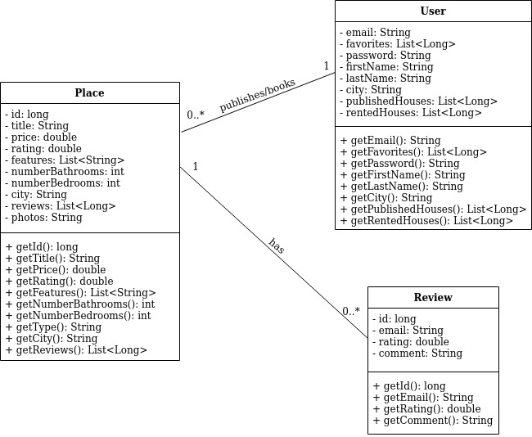

Architecture notebook

Key requirements and constraints
<Identify issues that will drive the choices for the architecture such as: Will the system be driven by complex deployment concerns, adapting to legacy systems, or performance issues? Does it need to be robust for long-term maintenance?
Identify critical issues that must be addressed by the architecture, such as: Are there hardware dependencies that should be isolated from the rest of the system? Does the system need to function efficiently under unusual conditions? Are there integrations with external systems? Is the system to be offered in different user-interfacing platforms (web, mobile devices, big screens,…)?
E.g.: (the references cited in [XX ] would be hypothetical links to previous specification documents/deliverables )
There are some key requirements and system constraints that have a significant bearing on the architecture. They are:
è The existing legacy Course Catalog System at Wylie College must be accessed to retrieve all course information for the current semester. The C-Registration System must support the data formats and DBMS of the legacy Course Catalog System [E2].
è The existing legacy Billing System at Wylie College must be interfaced with to support billing of students. This interface is defined in the Course Billing Interface Specification [E1].
è All student, professor, and Registrar functionality must be available from both local campus PCs and remote PCs with internet dial up connections.
è The C-Registration System must ensure complete protection of data from unauthorized access. All remote accesses are subject to user identification and password control.
è The C-Registration System will be implemented as a client-server system. The client portion resides on PCs and the server portion must operate on the Wylie College UNIX Server. [E2]
è All performance and loading requirements, as stipulated in the Vision Document [E2] and the Supplementary Specification [15], must be taken into consideration as the architecture is being developed.>

Architetural view
→ Discuss architecture planned for the software solution.
→ include a diagram

→ explain how the identified modules will interact. Use sequence diagrams to clarify the interactions along time, when needed
→ dicuss more advanced app design issues: integration with Internet-based external services, data synchronization strategy, distributed workflows, push notifications mechanism, distribution of updates to distributed devices, etc.>

Deployment architeture
[Explicar a organização prevista da solução em termos configuração de produção (deployment). Modelar num diagrama de deployment]

System architecture
<briefly present the software architecture. Include diagrams.>
<explain the supporting data models/data structures, i.e., the entities of your problem>
<detail the specific technologies/frameworks that were used>

The software architecture is presented in the next figure.

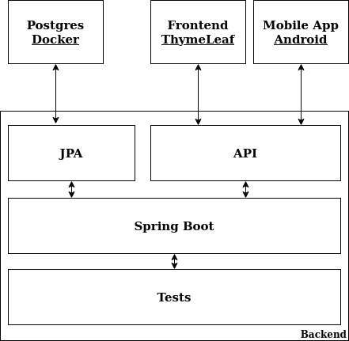

Given the above figure, for the backend it is being used Spring Boot, with the use of Controllers to respond to the API calls and the abstractions of JPA, capable of converting classes to database tables and vice versa. This database is a Postgres docker container, capable of storing all the data associated to the service like reviews, users and places. For the frontend, it was used HTML alongside with ThymeLeaf and the external service, using the API endpoints is an android application.

API for developers
[Explicar a organização da API. Os detalhes detalhes/documentação dos métodos devem ficar numa solução hosted de documentação de APIs, como o Swagger, ou https://apiary.io/ ]
<what services/resources can a developer obtain from your REST-API?>
<document the support endpoints>

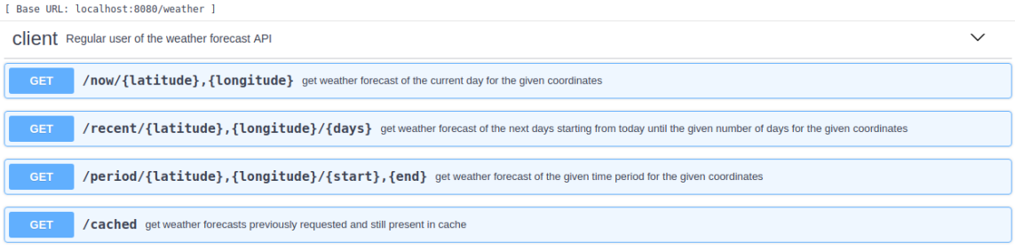

The API uses two main paths: the users and the places. For the users path, information about the users like his favorite houses or the houses that he booked. For the places endpoint, details about the place and reviews associated.
The documentation of the API can be found here.

References and resources
<document the key components (e.g.: libraries, web services) or key references (e.g.: blog post) used that were really helpful and certainly would help other students pursuing a similar work>

